**Unit 3 Review Sheet**

**Triangle Congruence**

1. Two triangles have the following pairs of congruent sides: **

and Write the congruence statement for the two triangles.

2. ∆*QRS* ≅ ∆*TUV .* Name the angle or side that corresponds to the given part.

a. ∠*Q* b.  c. ∠*S* d. 

3. State the postulate or theorem you can use to prove the pair of triangles congruent. If it is not possible, state that.



a. b. c.

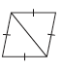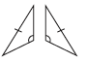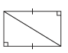d. e. f.

**Isosceles & Equilateral Triangles**

1. 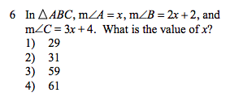
2. 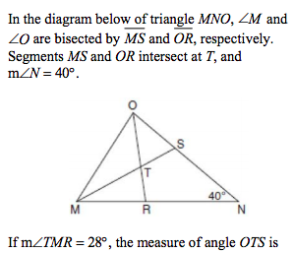 3.   
   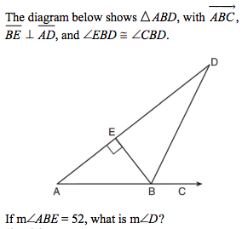

**Overlapping Triangles**

1. Redraw and separate the two overlapping triangles
2. Mark up the triangles with the given information
3. Name the overlapping congruent triangles
4. State whether the triangles are congruent by SSS, SAS, ASA, AAS, or HL.

1. Given: ∠*ABC* ≅ ∠*DCB;* ∠*DBC* ≅ ∠*ACB*

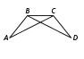

2. Given: ∠*E* ≅ ∠*D* ≅ ∠*DCF* ≅ ∠*EFC*

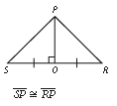Proof #1

Given:

*SO=OR*

*PO $⊥$ SR*

Prove:

SP≅ RP

Proof #2

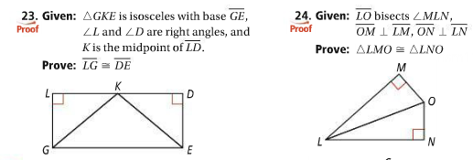

Proof #3

